

Safeguarding Policy

for local churches



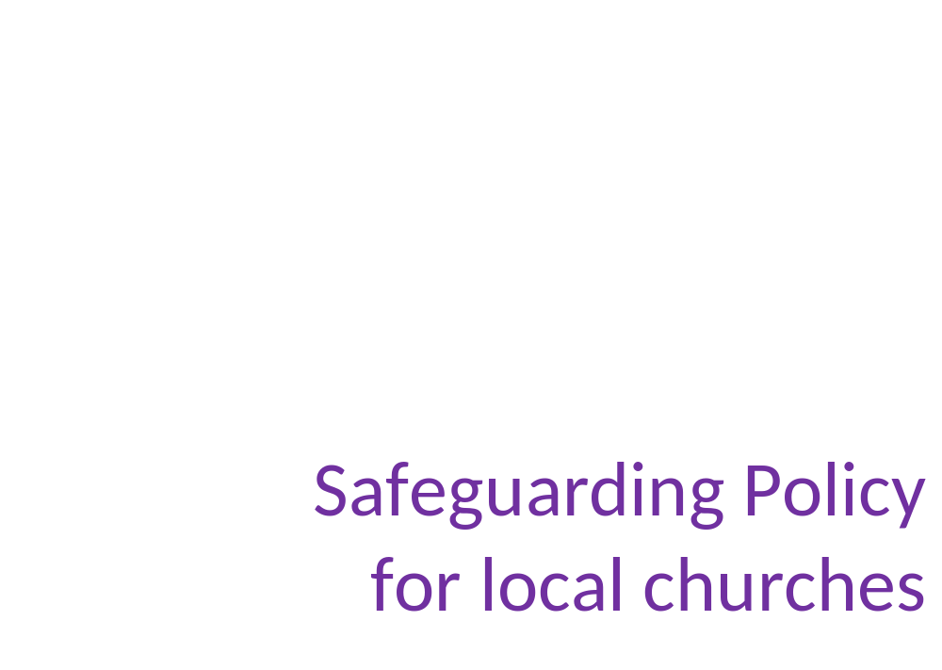

Heald Green United Reformed Church
North Western Synod
April 2018

© The United Reformed Church
Published by the United Reformed Church
All rights reserved

Designed by Church House graphics office
Printed in Church House, The United Reformed Church
86 Tavistock Place, London WC1H 9RT

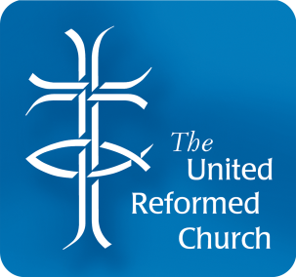

Introduction

Safeguarding is taken seriously by
Heald Green United Reformed Church
We acknowledge children’s and adults’ right to protection from abuse regardless of gender, ethnicity, disability, sexuality or beliefs. We consider that the welfare of children is paramount. We will follow legislation, statutory guidance and recognised good practice in order to protect vulnerable people in our church.
We will seek to establish a caring environment in which there is an informed vigilance about the dangers of abuse.
We will implement, maintain and regularly review the procedures outlined in this policy, which are designed to prevent and to be alert to such abuse.
We will appoint a Safeguarding Coordinator and Deputy Safeguarding Coordinator, who will have specific responsibilities for safeguarding, although we recognise that safeguarding is a whole church responsibility. The Safeguarding Coordinator is the person to whom all concerns or allegations should be addressed. In the absence of the Safeguarding Coordinator, the Deputy Safeguarding Coordinator should be contacted. Their contact details can be found in Key Contacts, P7.
We will organise activities in such a way as to promote a safe environment and minimise the risk of harm to children and adults.
When recruiting on a voluntary basis and it is a person known within the Church safe we will follow a safe but less rigorous selection process.
We will follow a safer recruitment process for the selection and appointment of people to work with children or adults at risk, when paid.
We are committed to providing support, supervision, resources and offer appropriate training to those who work with children and adults.
We will use rigorous and careful supervision to protect people from the risks associated with known offenders within the congregation, including implementing contracts with known offenders and those who have been assessed as posing a risk.
We believe that domestic abuse in all its forms is unacceptable and inconsistent with a Christian way of living and recognised that it can affect both adults and children.
All concerns and allegations of abuse will be responded to appropriately, including referring to the statutory authorities if necessary.

We will co-operate with the statutory authorities in any investigation, will follow multi-agency decisions and will maintain confidentiality of any investigations to those directly involved.

We will refer concerns about staff – volunteers and paid, lay and ordained – that meet the relevant criteria to the Local Authority Designated Officer.

Our Safeguarding Policy Statement is attached as Appendix A1.

Aim and purpose of this policy
The aim of this policy is to provide procedures for promoting safeguarding, preventing abuse and protecting children, adults at risk and staff. This includes clear procedures for taking appropriate action when safeguarding concerns are raised involving children and adults within our church, or those who attend our activities and events.

Who this policy applies to
This policy is approved and endorsed by the Elders and applies to:
- all those who attend our church
- our trustees and staff (both paid and voluntary)
- organisations who hire our building with agreement to operate under the church safeguarding policy. If organisations have their own policy, the church must hold a copy of their document on record with the lettings agreement document.

The policy and procedures should be interpreted in the light of the most recent URC good practice guidance. Children and parents/carers will be informed of this policy and our procedures.
The term ‘children’ refers to those under the age of 18 years.

Duty of care and confidentiality
We have a duty of care to all beneficiaries of the church, whether adults or children. We will maintain confidentiality at all times, except in circumstances where to do so would place the individual or another individual at risk of harm.

Preventing abuse
The church will appoint Safeguarding and Deputy Safeguarding Coordinator(s) for safeguarding children and adults. A job description is attached as Appendix A2.
Activities will be organised in accordance with URC good practice guidelines so as to promote a safe environment and healthy relationships, whilst minimising opportunities for harm, misunderstanding or false accusation. For each event, risk assessments will be carried out, appropriate consent forms will be used (for children’s activities), appropriate records will be kept and adequate insurance will be in place.
When recruiting on a voluntary basis and it is a person known within the Church safe we will follow a safe but less rigorous selection process.
We will follow a safer recruitment process for the selection and appointment of people to work with children or adults at risk, when paid.

We are committed to safer recruitment and selection of all paid staff and volunteers and will ensure that these procedures are followed, which will include:
- asking for a paid role applicants to complete an application form
- advising workers of their job descriptions and person specifications
- obtaining Disclosure and Barring Service (DBS) / Protecting Vulnerable Groups scheme (PVG) checks wherever legally entitled to do so
- taking up two references (not from family members) - this can be verbal references
- Informally interviewing candidates

Safeguarding training will be provided and paid staff will be given support and supervision in their role and made available to volunteers where required.

All trustees, paid staff and volunteers will work within a code of conduct (code for workers attached as Appendix A3) and understand that there may be action taken if this code is not followed, possibly involving suspension or termination of working with us.
If we become aware of someone within our congregation known to have harmed children or adults in the past, we will inform the Synod Safeguarding Officer and co-operate with them and the relevant statutory authorities to put in place a plan to minimise the risk of harm to children and adults.
Organisations wishing to hire our building for activities with children or adults must confirm in writing that they will follow the principles of this safeguarding policy as a condition of the letting agreement. If they have their own safeguarding policy, they will be asked to provide a copy.
If they do not have their own safeguarding policy, the church will encourage them to adopt one before agreeing to the hire, or may agree that they can follow the church safeguarding policy
and procedures.

What are we protecting people from?
The definitions of abuse differ between children and adults. A copy of the definitions relating to children is attached to this policy at Appendix A4. The definitions of abuse in relation to adults is attached as Appendix A5.

How to recognise abuse
It is important to be aware of possible signs and symptoms of abuse. Please see Appendix A6 for those relating to children and Appendix A7 for those relating to adults at risk. Some signs could be indicators of a number of different categories of abuse.
It is essential to note that these are only indicators of possible abuse. There may be other, innocent, reasons for these signs and/or behaviour. They will, however, be a guide to assist in assessing whether abuse of one form or another is a possible explanation for a child or adult’s behaviour.

What to do if there is a disclosure or allegation of abuse
If a child, young person or adult makes a disclosure that they are being abused and / or an allegation of abuse against someone, it is important that the person being told:

- stays calm and listen carefully
- reassures them that they have done the right thing in telling
- does not investigate or ask leading questions
- explains that they will need to tell someone else if anyone is at risk of harm, in order to help them
- does not promise to keep secret what they have been told
- informs the church Safeguarding Coordinator as soon as possible (if they are implicated in the allegation, inform the Deputy or the Synod Safeguarding Officer)
- makes a written record of the allegation, disclosure or incident and signs and dates this record (using the template in Appendix A8). This should be given to the church Safeguarding Coordinator and stored securely in a locked filing cabinet

Procedure in the event of a concern of abuse
If there is an immediate threat of harm, the Police should be contacted without delay.

Where it is judged that there is no immediate threat of harm the following will occur:
- The concern should be discussed with the Church Safeguarding Coordinator and a decision made as to whether the concern warrants a referral to statutory authorities (see Key Contacts, P7 for the relevant statutory contacts)
- A confidential record will be made of the conversation and the circumstances surrounding it using the template at Appendix A8. This record will be kept securely and a copy passed to statutory authorities if a referral is made
- The person about whom the allegation is made must not be informed by anyone in the church if it is judged that to do so could place a child or adult at increased risk. If the statutory authorities are involved, they should be consulted beforehand
- The Synod Safeguarding Officer should be kept informed of any serious concerns

If someone in the church is alleged or known to have harmed children or adults we will inform the Synod Safeguarding Officer so that they can offer advice and support, and we will contact the relevant statutory authority.

If the allegation is regarding a church staff member or church volunteer
For any concerns relating to children, the Local Authority Designated Officer (LADO) or the equivalent in Scotland and Wales will be contacted. The timing and method of any action to be taken will be discussed and agreed with the LADO. This will cover communication with the worker, suspension, investigation and possible strategy meetings. A decision will be taken by the LADO about when to inform the worker and the church will follow this advice. For LADO contact details, see Key Contacts, P7.

For concerns relating to adults, Adult Social Care will be contacted. See Key Contacts, P7 for details.

In accordance with the law, a referral will be made to the DBS / PVG if the church withdraws permission for an individual to engage in work with children / adults at risk OR would have done so had that individual not resigned, retired, been made redundant or been transferred to a position because the employer believes that the individual has engaged in relevant conduct, satisfied the harm test or committed an offence that would lead to automatic inclusion on a barred list.

In such cases, a report will also be made to the Charity Commission, as they deem such a referral to be a ‘serious incident’ and requires notification.

Concerns, Complaints and Compliments
Should anyone have any concerns, complaints or compliments please contact:

Name: Mrs Margaret Smethurst

Telephone No 0161 286 2645

Email mastonrock@hotmail.com

If would be helpful to have complaints in writing, as this avoids any possible misunderstanding about what the issue is. However, whether verbal or in writing, complaints will be acted upon.
Any written complaint will be responded to within 21 days

Review
The Elders will review this policy annually, amending and updating it as required, and informing Church Meeting that this has been done.

Date of the most recent review:

Date of the next review:

Signed:
(on behalf of the church Elders)

Key Contacts: Sources of advice and support
- The church Safeguarding Coordinator is the person to whom all concerns or allegations should be addressed:

Name Mrs Margaret Smethurst

Telephone No 0161 286 2645

Email mastonrock@hotmail.com

- In the absence of the Safeguarding Coordinator, the Deputy Safeguarding Coordinator
can be contacted:
Name Alison Haigh

Telephone No 0161 485 2050

Email alisoncmhaigh@gmail.com

- Synod Safeguarding Officer

Name Julie Rafferty

Telephone No 07376 053044

- Email safeguarding@nwsynod.org.uk
- Churches Child Protection Advisory Service (CCPAS) (This should only be used for urgent advice if you are unable to contact your Synod Safeguarding Officer)
24 hour helpline: 0845 120 4550

- Local Authority Services

- Child Services
0161 217 6028 (out of hours) 0161 718 2118

- Adult services
0161 217 6029 (out of hours) 0161 718 2118

Appendix A3
Code of Conduct for working with children or young people
Appendix A3

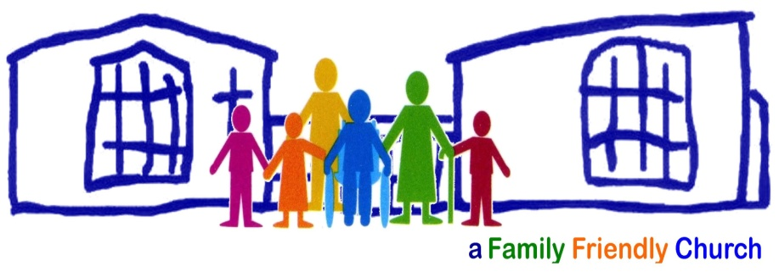

Safeguarding Policy Statement

The following statement has been agreed by The Leadership of Heald Green United Reformed Church.
This church is committed to the safeguarding of children & adults at risk, and to ensure their well-being by:
PROMOTING SAFEGUARDING
PREVENTING ABUSE
PROTECTING EVERYONE
- We recognise that safeguarding is a whole church responsibility.
- We believe that all children and adults at risk should know that they are valued within the church and safely enjoy and have access to all aspects of the life of our church
- We respect the personal dignity and rights of children and adults at risk (e.g. as set out in the Human Rights Act 1989 and UN Convention on the Rights of the Child) and will ensure that our policies and procedures reflect this.
- We recognise that we all have a responsibility to help prevent the physical, sexual, emotional abuse and neglect of children under 18 years of age and report it accordingly.
- We recognise that we all have a responsibility to help prevent the physical, sexual, emotional abuse and neglect of adults at risk and report it accordingly.
- We recognise that domestic abuse affects both adults and children and believe that domestic abuse in all its forms is unacceptable and inconsistent with the Christian way of life.
- Where we identify concerns of the welfare of a child or & adult at risk. We will take action to address them in partnership with the relevant /appropriate organisations.

Key Contacts: Sources of advice and support
The Church Safeguarding Coordinator is the person to whom all concerns or allegations should be addressed:
Name: Mrs Margaret Smethurst Telephone Number: 0161 286 2645
E Mail: mastonrock@hotmail.com
In the absence of the Safeguarding Coordinator, the Deputy Safeguarding Coordinator can be contacted:
Name: Mrs Alison Haigh Telephone Number: 0161 485 2050
E Mail: alisoncmhaigh@gmail.com
Synod Safeguarding Officer:
Name: Julia Rafferty Telephone Number: 07376 053044
E Mail: safeguarding@nwsynod.org.uk

 Appendix A1
Safeguarding Policy Statement
Churches Child Protection Advisory Service (CCPAS) – only for urgent advice of you are unable to contact the Synod Safeguarding Officer: 24 hour helpline 0845 120 4550

Local Authority Services:
Children's services 0161 217 6028 (out-of-hours) 0161 718 2118
Adult services 0161 217 6029 (out-of-hours) 0161 718 2118

Other useful contacts
Churches Child Protection Advisory Service (CCPAS): 0845 120 45 50 (Children Vulnerable Adults)
Childline: 0800 800 1111
NSPCC: 0808 800 5000
Kidscape (Advice and Helpline regarding Bullying): 08451 205 204

Name:
(on behalf of the church leadership)

Signed:

Date:

Appendix A2
The Role of a Church Safeguarding Coordinator

Safeguarding Policy Statement

The following statement has been agreed by The Leadership of Heald Green United Reformed Church.
This church is committed to the safeguarding of children & adults at risk, and to ensure their well-being by:
PROMOTING SAFEGUARDING
PREVENTING ABUSE
PROTECTING EVERYONE
- We recognise that safeguarding is a whole church responsibility.
- We believe that all children and adults at risk should know that they are valued within the church and safely enjoy and have access to all aspects of the life of our church
- We respect the personal dignity and rights of children and adults at risk (e.g. as set out in the Human Rights Act 1989 and UN Convention on the Rights of the Child) and will ensure that our policies and procedures reflect this.
- We recognise that we all have a responsibility to help prevent the physical, sexual, emotional abuse and neglect of children under 18 years of age and report it accordingly.
- We recognise that we all have a responsibility to help prevent the physical, sexual, emotional abuse and neglect of adults at risk and report it accordingly.
- We recognise that domestic abuse affects both adults and children and believe that domestic abuse in all its forms is unacceptable and inconsistent with the Christian way of life.
- Where we identify concerns of the welfare of a child or & adult at risk. We will take action to address them in partnership with the relevant /appropriate organisations.

Key Contacts: Sources of advice and support
The Church Safeguarding Coordinator is the person to whom all concerns or allegations should be addressed:
Name: Mrs Margaret Smethurst Telephone Number: 0161 286 2645
E Mail: mastonrock@hotmail.com
In the absence of the Safeguarding Coordinator, the Deputy Safeguarding Coordinator can be contacted:
Name: Mrs Alison Haigh Telephone Number: 0161 485 2050
E Mail: alisoncmhaigh@gmail.com
Synod Safeguarding Officer:
Name: Julia Rafferty Telephone Number: 07376 053044
E Mail: safeguarding@nwsynod.org.uk

Context
We believe that children and adults at risk deserve the best possible care that the church can provide and that the church should be a safe place for everyone involved.
We recognise and give thanks for the time and devotion given by anyone carrying out this role.

Purpose of the role:
- To coordinate safeguarding policy and procedure in the church.
- To be the first point of contact for safeguarding issues.
- To be an advocate for good safeguarding practice in the church.

Responsibilities
To coordinate safeguarding policy and procedure in the church
- To familiarise themselves with church policies and procedures and URC good practice guidelines in safeguarding and to keep abreast of any changes and developments.
- To ensure that church policies and procedures are reviewed annually, kept up to date,
and are fit for purpose.
- To make others in the church aware of the church safeguarding policies and procedures,
as well as URC guidelines.
- To ensure safer recruitment practices are operated in the recruitment of all workers
(both volunteers and paid) including, but not exclusively, ensuring that the relevant workers have up to date Disclosure and Barring Service (DBS) / Protecting Vulnerable Groups scheme (PVG) checks.

To be the first point of contact for safeguarding issues
- To be a named person that children / adults at risk, church members and outside
agencies can talk to regarding any issue to do with safeguarding.
- To be aware of the names and telephone numbers of appropriate contacts within Social Care and the Police in the event of a referral needing to be made.
- To be aware of when to seek advice, and when it is necessary to inform Social Care, the Police or the Local Authority Designated Officer (LADO) or the equivalent in Scotland and Wales of a concern or incident.
- To take appropriate action in relation to any safeguarding concerns which arise within
the church.
- To cooperate with Social Care or the Police in safeguarding investigations relating to people within the church.

- To ensure that appropriate records are kept by the church, and that information in relation to safeguarding issues is handled confidentially and stored securely.
- To inform the Synod Safeguarding Officer at the time of any referrals made to the statutory authorities, or of any information received from the statutory authorities.
- To report summary safeguarding information annually to the Synod Safeguarding Officer to enable them to monitor safeguarding in the Synod.

To be an advocate for good safeguarding practice in the church
- To promote sensitivity within the church towards all those affected by the impact of abuse.
- To promote positive safeguarding procedures and practice and ensure procedures are adhered to.
- To arrange and/or promote opportunities for training in safeguarding to any relevant members of the leadership team and congregation, including both paid staff and volunteers.
- To update their own safeguarding training every three years.
- To seek appropriate support and advice in carrying out this role.
- To make arrangements for a suitable person to carry out this role when they are on leave, and to publicise who this is and the dates of the alternative arrangements.

Appendix A3
Code of Conduct for working with children or young people
Appendix A3
Code of Conduct for working with children or young people

We should all be aware that behaviour in a worker's personal life (including online) may impact upon their work with children or young people. Therefore, all workers should agree not to behave in a manner which would lead any reasonable person to question their suitability to work with children or act as a role model within the United Reformed Church.

All workers should agree to the following code of conduct when working with children and
young people:

- Do treat all people with dignity and respect
- Don't abuse the power and responsibility of your role. Don’t belittle, scapegoat, put down, or ridicule a child or young person (even in 'fun') and don't use language or behaviour with sexual connotations (e.g. flirting or innuendo)
- Do act inclusively, seeking to make everyone feel welcome and valued
- Don't exclude other children or workers from conversations and activities unless there is a good reason
- Do treat people with equal care and concern
- Don't show favouritism (e.g. in selection for activities, in giving rewards, etc) or encourage excessive attention from a particular child (e.g. gifts)
- Do encourage everyone to follow any behaviour agreement or ground rules and apply sanctions consistently
- Don't threaten or use sanctions which have not been agreed, or make empty threats
- Do refer to a more senior worker if a child does not respond to your instructions despite encouragement and warning of possible consequences
- Don’t feel you have to deal with every problem on your own
- Do seek to diffuse aggressive or threatening behaviour without the use of physical contact
- Don't use physical restraint except as a last resort to prevent injury. This should use minimum force
- Do relate to children in public. If a child wants to talk one-to-one about an issue, tell another worker and find somewhere quieter, but still public, to talk
- Don't spend time alone with children out of sight of other people
- Do make sure that any electronic communication is done with parental consent and is transparent, accountable, recorded and adheres to safeguarding policies
- Don't keep communication with children secret, while still respecting appropriate confidences
- Do have a designated photographer to take, store and share photos of your group’s activities, in line with URC good practice guidelines
- Don’t take photos or videos without consent, store them in a safe place designated by the church and only use them in the ways agreed, in line with URC good practice guidelines

- Do use physical contact wisely; it should be:
  - in public
  - appropriate to the situation and to the age, gender and culture of the child
  - in response to the needs of the child, not the adult
  - respectful of the child's privacy, feelings and dignity
- Don't use physical contact which could be misconstrued as aggressive (e.g. rough games) or sexual
- Do respect children's privacy
- Don't assume that children should tell you anything you ask just because you are a worker
- Do respect the right of children to wash, change and use the toilet in private
- Don’t walk in unnecessarily or unannounced
- Do listen to children and tell the church Safeguarding Coordinator if you have any concerns about a child's welfare
- Don't promise to keep something secret if it is about a child being harmed or at risk of harm, but only tell those who need to know
- Do respect and promote the rights of children to make their own decisions and choices
- Don’t work in ways that put your needs and interests before those of the children you work with
- Do encourage respect for difference, diversity, beliefs and culture
- Don’t discriminate or leave discrimination or bullying unchallenged

I agree to abide by the above code of conduct while working with children and young people

on behalf of
[church name]

Name of worker:

Signed:

Date:

Appendix A4
What is abuse and neglect of children?

The below definitions are taken from Working Together to Safeguard Children 2013 and apply to
England. Please note that there are national variations for Scotland (National Guidance for Child
Protection in Scotland 2014) and Wales (All Wales Child Protection Procedures 2008).

Abuse and neglect are forms of maltreatment of a child. Somebody may abuse or neglect a child by inflicting harm, or by failing to act to prevent harm. Children may be abused in a family or in an institutional or community setting, by those known to them or, more rarely, by a stranger, for example, via the internet. They may be abused by an adult or adults, or another child or children.

Physical abuse
Physical abuse may involve hitting, shaking, throwing, poisoning, burning or scalding, drowning, suffocating, or otherwise causing physical harm to a child. Physical harm may also be caused
when a parent or carer fabricates the symptoms of, or deliberately induces, illness in a child.

Emotional abuse
Emotional abuse is the persistent emotional maltreatment of a child such as to cause severe and persistent adverse effects on the child’s emotional development.

It may involve conveying to a child that they are worthless or unloved, inadequate, or valued only insofar as they meet the needs of another person. It may include not giving the child opportunities to express their views, deliberately silencing them or ‘making fun’ of what they say or how they communicate. It may feature age or developmentally inappropriate expectations being imposed on children. These may include interactions that are beyond the child’s developmental capability, as well as overprotection and limitation of exploration and learning, or preventing the child from participating in normal social interaction. It may involve seeing or hearing the ill-treatment of another. It may involve serious bullying (including cyberbullying), causing children frequently to feel frightened or in danger, or the exploitation or corruption of children.

Some level of emotional abuse is involved in all types of maltreatment of a child, though it may occur alone.

Sexual abuse
Sexual abuse involves forcing or enticing a child or young person to take part in sexual activities, not necessarily involving a high level of violence, whether or not the child is aware of what is happening.

The activities may involve physical contact, including assault by penetration (for example, rape or oral sex) or non-penetrative acts such as masturbation, kissing, rubbing and touching outside of clothing. They may also include non-contact activities, such as involving children in looking at,
or in the production of, sexual images, watching sexual activities, encouraging children to
behave in sexually inappropriate ways, or grooming a child in preparation for abuse (including
via the internet).

Sexual abuse is not solely perpetrated by adult males. Women can also commit acts of sexual abuse, as can other children.

Neglect
Neglect is the persistent failure to meet a child’s basic physical and/or psychological needs, likely to result in the serious impairment of the child’s health or development. Neglect may occur during pregnancy as a result of maternal substance abuse. Once a child is born, neglect may involve a parent or carer failing to:
- provide adequate food, clothing and shelter (including exclusion from home or abandonment)
- protect a child from physical and emotional harm or danger
- ensure adequate supervision (including the use of inadequate care-givers)
- ensure access to appropriate medical care or treatment

It may also include neglect of, or unresponsiveness to, a child’s basic emotional needs.

Appendix A5
What is abuse of adults at risk?

Abuse is a violation of an individual’s human and civil rights by any other person or persons.
Abuse may consist of a single act or repeated acts. It may be physical, verbal or psychological,
it may be an act of neglect or an omission to act, or it may occur when a vulnerable per son is persuaded to enter into a financial or sexual transaction to which he or she has not consented,
or cannot consent. Abuse can occur in any relationship and may result in significant harm to,
or exploitation of, the person subjected to it.

Physical abuse
This is the infliction of pain or physical injury, which is either caused deliberately, o r through
lack of care.

Psychological or emotional abuse
These are acts or behaviour, which cause mental distress or anguish or negate the wishes of the adult at risk. It is also behaviour that has a harmful effect on the adult at risk’s emotional health and development or any other form of mental cruelty.

Sexual abuse
This is the involvement in sexual activities to which the person has not consented or does not truly comprehend and so cannot give informed consent or where the other party is in a position of trust, power or authority and uses this to override or overcome lack of consent.

Neglect or Act of Omission
This is the repeated deprivation of assistance that the adult at risk needs for important activities of daily living, including the failure to intervene in behaviour which is dangerous to the adult at risk or to others. A vulnerable person may be suffering from neglect when their general well being or development is impaired.

Financial or material abuse
This is the inappropriate use, misappropriation, embezzlement or theft of money, property or possessions.

Discriminatory abuse
This is the inappropriate treatment of an adult at risk because of their age, gender, race, religion, cultural background, sexuality, disability, etc. Discriminatory abuse exists when values, beliefs or culture result in a misuse of power that denies opportunity to some groups or individuals. Discriminatory abuse links to all other forms of abuse.

Institutional abuse
T his is the mistreatment or abuse of an adult at risk by a regime or individuals within an institution (e.g. hospital or care home) or in the community. It can be through repeated acts of poor or inadequate care and neglect or poor professional practice.
Appendix A6
Signs of possible abuse in children

• Physical abuse

Physical signs include:
- Unexplained injuries
- Injuries that are inconsistent with the explanation
- Injuries that reflect an article being used e.g. an iron
- Bruising, especially the trunk, upper arm, shoulders, neck or finger tip bruising
- Burns/scalds, especially from a cigarette
- Human bite marks
- Fractures, especially spiral
- Swelling and lack of normal use of limbs
- Serious injury with lack of / inconsistent explanation
- Untreated injuries

Psychological/emotional signs include:
- Unusually fearful with adults
- Unnaturally compliant to parents
- Refusal to discuss injuries/fear of medical help
- Withdrawal from physical contact
- Aggression towards others
- Wears cover up clothing

Factitious illness by proxy
- This is a psychiatric illness, whereby a parent or carer deliberately inflicts harm onto a child, normally the child’s mother. The child has commonly had genuine serious illness in the first year of life and a dependency on medical attention has developed in the mother. It is very difficult to diagnose/evidence.

Female Genital Mutilation
- A cultural (not religious) procedure whereby parts of female genitalia are removed – also referred to as female circumcision. This is normally undertaken on pre pubescent girls who are either taken abroad for procedure or “practitioners” come to the UK. There can be no anaesthetic and no sterile equipment used. Complications include serious infection, septicaemia, numerous gynaecological problems and in some cases, death.

• Emotional abuse

The classic description of emotional abuse is a “Low Warmth, High Criticism” style of parenting.

Signs include:
- Physical, mental and emotional lags
- Acceptance of punishments, which appear excessive
- Over reaction to mistakes
- Continual self-depreciation
- Sudden speech disorders
- Fear of new situations
- Neurotic behaviour (such as rocking, hair twisting, thumb sucking)
- Self harm
- Extremes of passivity or aggression
- Drug/solvent abuse
- Running away
- Bullying/Aggression
- Overly compliant behaviour
- Overeating or loss of appetite
- Clingy
- Fearful/withdrawn
- Sleep disorders

• Neglect

Physical signs include:
- Tired/listless
- Poor personal hygiene
- Poor state of clothing
- Emaciation, potbelly, short stature
- Poor skin tone and hair tone
- Untreated medical problems
- Failure to thrive with no medical reason

Psychological/emotional signs include:
- Constant hunger
- Constant tiredness
- Frequent lateness/non attendance at school
- Destructive tendencies
- Low self esteem
- Neurotic behaviour
- No social relationships
- Running away
- Compulsive stealing/scavenging
- Multiple accidents/accidental injuries

• Sexual abuse

Physical signs include:
- Damage to genitalia, anus or mouth
- Sexually transmitted disease
- Unexpected pregnancy, especially in very young girls
- Soreness to genitalia area, anus or mouth
- Repeated stomach aches
- Loss of weight
- Gaining weight
- Unexplained recurrent urinary tract infections, discharges or abdominal pain
- Unexplained gifts/money

Psychological/emotional signs include:
- Sexual knowledge inappropriate for the child’s age
- Sexualised behaviour in young children
- Sexually provocative behaviour/promiscuity
- Hinting at sexual activity
- Sudden changes in personality
- Lack of concentration, restlessness
- Socially withdrawn
- Overly compliant behaviour
- Poor trust in significant adults
- Regressive behaviour, onset of wetting – day or night
- Suicide attempts, self mutilation, self disgust
- Eating disorders

Appendix A7
Signs of possible abuse in adults

Physical
- A history of unexplained falls, fractures, bruises, burns, minor injuries
- Signs of under or over use of medication and/or medical problems unattended

Psychological
- Alteration in psychological state e.g. withdrawn, agitated, anxious, tearful
- Intimidated or subdued in the presence of the carer
- Fearful, flinching or frightened of making choices or expressing wishes
- Unexplained paranoia

Sexual
- Pregnancy in a woman who is unable to consent to sexual intercourse
- Unexplained change in behaviour or sexually implicit/explicit behaviour
- Torn, stained or bloody underwear and/or unusual difficulty in walking or sitting
- Infections or sexually transmitted diseases
- Full or partial disclosure or hints of sexual abuse
- Self-harming

Neglect or Omission
- Malnutrition, weight loss and /or persistent hunger
- Poor physical condition, poor hygiene, varicose ulcers, pressure sores
- Being left in wet clothing or bedding and/or clothing in a poor condition
- Failure to access appropriate health, educational services or social care
- No callers or visitors

Financial or Material
- Disparity between assets and living conditions
- Unexplained withdrawals from accounts or disappearance of financial documents
- Sudden inability to pay bills
- Carers or professionals fail to account for expenses incurred on a person’s behalf
- Recent changes of deeds or title to property

Discriminatory
- Inappropriate remarks, comments or lack of respect
- Poor quality or avoidance of care

Institutional
- Lack of flexibility or choice over meals, bed times, visitors, phone calls, etc
- Inadequate medical care and misuse of medication
- Inappropriate use of restraint
- Sensory deprivation e.g. denial of use of spectacles or hearing aids
- Missing documents and/or absence of individual care plans
- Public discussion of private matter
- Lack of opportunity for social, educational or recreational activity

Appendix A8
Safeguarding Incident Recording Form

Basic information
Full name of child, young person or adult concerned
Address (including postcode)

Email address
Telephone number
Date of birth
Date and time of incident
Location of incident

Other people present (witnesses)

Record of incident
Please ensure you are as accurate and detailed as possible. Use quotes wherever possible – do not interpret what was said using your own words.

Include details such as tone of voice, facial expression and body language.

Record what you said as well as what the child, young person or adult said.

If you have formed an opinion please state it, making it clear that it is your opinion and give reasons for forming that opinion.

Who has been spoken to about the incident?
Position/Organisation | Name | Email | Telephone number
Church Safeguarding Coordinator

Synod Safeguarding Officer

Children’s Services

Adult Services

Police

NSPCC

Parent/Carer

Other (please state role and organisation

Feedback and follow up actions (continue on a separate sheet if necessary)

Name:
(person who completed this report)

Position held in the church:

Signed:

Dated:

